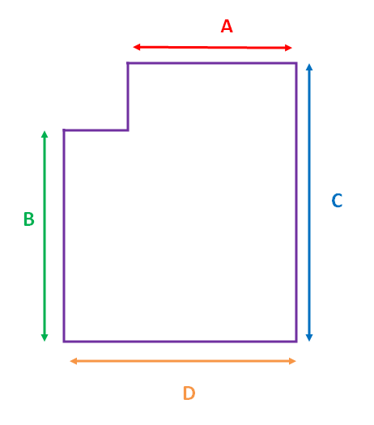
Medida, Mesure, Measure, A = ………..
Medida, Mesure, Measure, B = ……….
Medida, Mesure Measure, C = ………..
Medida, Mesure, Measure, D = ………..

Altura colchón =……. Mattress thickness =…… Épaisseur du matelas =……

